Final Project

Jon K. Jacobson
Bellevue University
DSC650-T301 2261-1: Big Data
Dr. Nasheb Ismaily
November 23, 2025

Introduction
This final project will take a dataset on social media use and mental health through a big data pipeline. We’ll perform machine learning (logistic regression) and store the evaluation metrics along with the details about the model that was used. After discussing the dataset and pipeline, I’ll go over the challenges that were overcome. Then I’ll go through each objective with screenshots and commentary. At the end I will provide the full code used during the machine learning job and my conclusions.
Dataset
Our dataset presents both social media use and various mental health factors. The data is of high enough quality that it could support many kinds of machine learning models. However, we will be using a logistic regression model to predict whether the user will be happy (>7) or not.
The original dataset, with its context and accompanying metadata, is available at https://www.kaggle.com/datasets/ayeshaimran123/social-media-and-mental-health-balance. The raw dataset is available at https://raw.githubusercontent.com/hegemogy/bigdata/refs/heads/main/Mental_ Health_and_Social_Media_Balance_Dataset.csv.
This dataset has five hundred rows with user data on their social media use and mental health. Here are all the columns included:
- User_ID
- Age
- Gender
- Daily_Screen_Time (hrs)
- Sleep_Quality (1-10)
- Stress_Level (1-10)
- Days_Without_Social_Media
- Exercise_Frequency (week)
- Social_Media_Platform
- Happiness_Index (1-10)
Pipeline Overview
Our data pipeline starts with ingesting the data. We will be using NiFi to manage three processors: one to pull the data via HTTP, one to name the file, and one to put that file into distributed storage (HDFS). NiFi is commonly used to orchestrate big data workflows and HDFS is a common distributed storage mechanism. Once in distributed storage, we will be using Hive, which is a SQL engine on top of HDFS. We create and load a table with our data, all backed by HDFS. Next we run a spark job which contains our machine learning model. This runs in a distributed fashion and sends the metrics from the model to HBase, which is a NoSQL database backed by HDFS. Across the pipeline, we leverage big data technologies so that the whole workflow could scale immensely as long as additional resources were provided.
Issues Encountered
The primary issues I encountered were syntax issues in the python code. These were common misspellings, missing commas, and other similar issues. I had set up VSCode to work directly on the server, which made debugging, fixing, and re-running the code much faster than it would have been. Another issue I ran into was self-inflicted by creating two different column families. This made the data more complicated, and I had to work through several drafts before I found something that worked with the template with minimal changes. One last challenge was just the length of time that everything took. I had to install packages on three servers, but I can see that in a distributed setting with many servers you would need a way to do this in parallel. Also, there was quite a bit of extra time in running the spark job than a normal python script, meaning it took a little longer to get feedback on whether the script was correct or not. These are hints of the additional complexity and delay that can come with a distributed system.
Objective 1 – NiFi Data Ingestion into HDFS
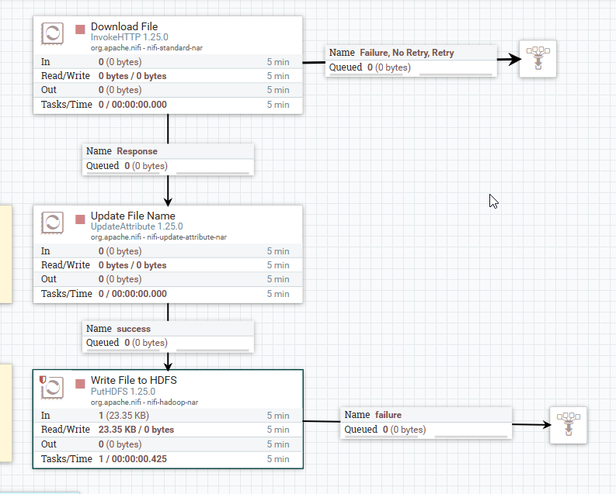
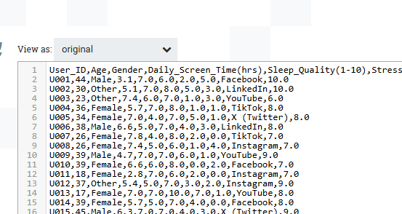
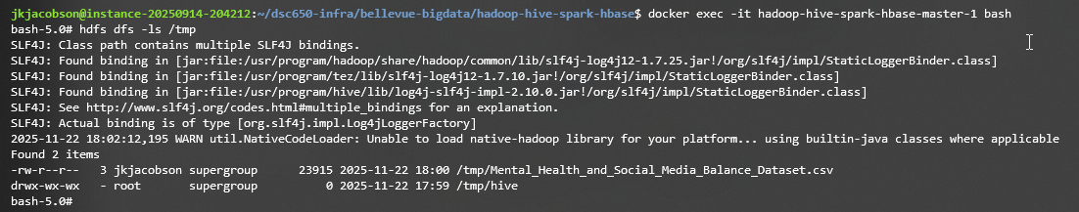The first screenshot shows the data has successfully made it through all three processors. The first reached out to the public github link to download the csv. The second processor changed the name to what was set in the parameter. The third processor put the renamed file onto /tmp in the HDFS filesystem. The second screenshot shows the data in the queue is actual CSV data. The last screenshot shows that the file was successfully loaded into HDFS.
Objective 2 – Hive Managed Table
CREATE TABLE user_social_media_data (
User_ID STRING,
Age INT,
Gender STRING,
Daily_Screen_Time DOUBLE,
Sleep_Quality INT,
Stress_Level INT,
Days_Without_Social_Media INT,
Exercise_Frequency INT,
Social_Media_Platform STRING,
Happiness_Index INT
)
ROW FORMAT DELIMITED
FIELDS TERMINATED BY ','
STORED AS TEXTFILE
TBLPROPERTIES ("skip.header.line.count"="1");

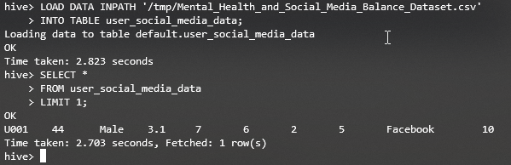
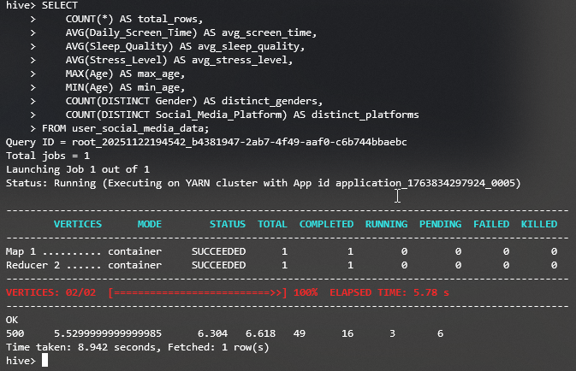

User_ID, Gender, and Social_Media_Platform are alphanumeric so they need to be type STRING. Daily_Screen_Time contains decimal values, so it needs to be a DOUBLE. Sleep_Quality, Stress_Level, Days_Without_Social_Media, Exercise_Frequency, and Happiness_Index are all integers (INT). We also added the delimiter and told Hive to ignore the header row, which matches the attributes of our file. If we needed better performance later, we could use ORC or PARQUET instead of TEXTFILE. The aggregation query shows useful baseline statistics for each column and verifies that the data has been loaded successfully.

Objective 3 – Environment Setup
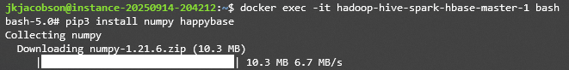
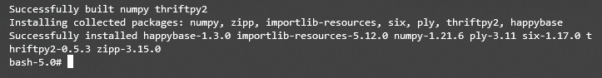
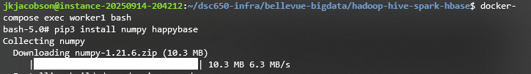
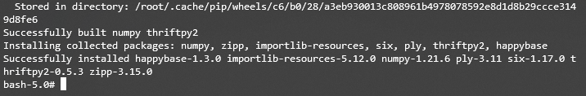
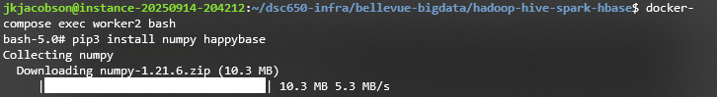
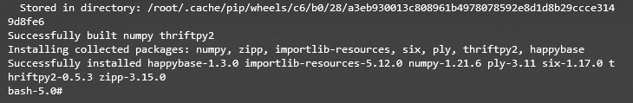
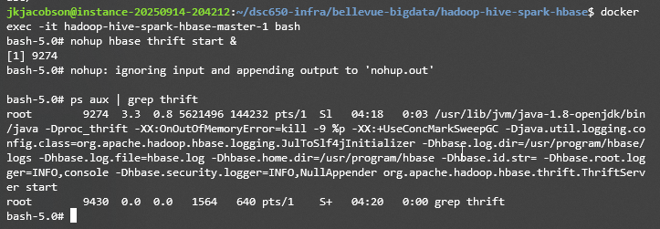
First, we installed the required libraries into the master and worker containers. This will be necessary to run the spark job using python shortly. We also started the thrift server which will allow our spark job to write its output to hbase. Without the libraries our python script would fail to execute. And without thrift running, our script would fail when it tried to write its output to hbase.

Objective 4 – HBase Table Creation
create 'ml_metrics', 'model_info', 'evaluation'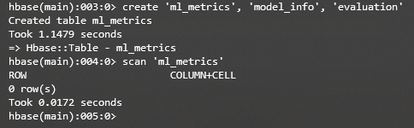
I created an hbase table called ‘ml_metrics’ with two column families. I intend to use ‘model_info’ to store attributes of the model, such as whether I’m using linear regression, logistic regression, etc. I also want to include the features that I’m using and any other data that helps identify which model it was. The second column family is for the actual metrics from the model, such as its accuracy, precision, recall, etc.
Objective 5 (PySpark ML Code) and Objective 6 (Spark Submit & Output)
Repo: https://github.com/hegemogy/bigdata/
Script: https://github.com/hegemogy/bigdata/blob/main/final_project.py
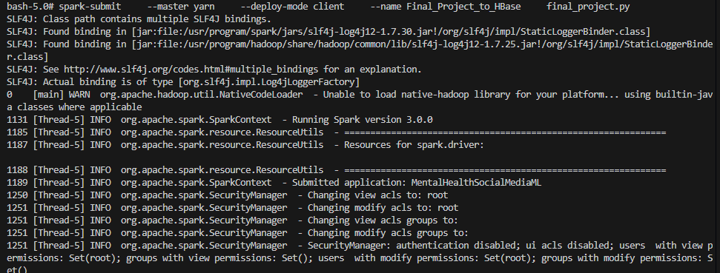
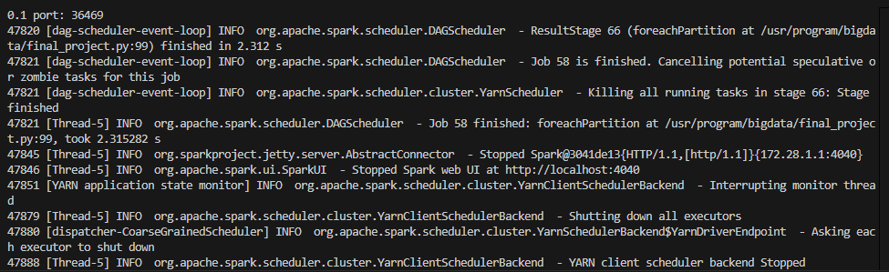
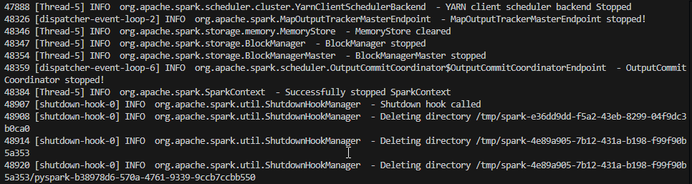In the first screenshot, you can see the full spark-submit command that was used to start the job, and you can see “Submitted application: MentalHealthSocialMediaML” which is the name of our application in our code. You can see in the second screenshot that “Job 58 finished: foreachPartition” and referencing the line and file of the job we ran. This is towards the end of the script, showing successful progress through writing to hbase. In the last screenshot, you can see all the shutdown activity continuing and the fact that we successfully stopped the spark context, which was the end of our script. Here are the metrics from within the logs:
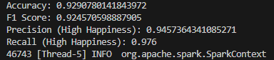
We used Logistic Regression to classify whether a user’s happiness level was high or low based on lifestyle and social media factors. This algorithm was chosen because it is simple, interpretable, and well-suited for binary outcomes, allowing us to see how each variable influences happiness probability. The model achieved strong results, with nearly 93% accuracy, an F1 score of 92%, and very high precision (95%) and recall (98%), showing it rarely misclassifies. Overall, the results demonstrate that the model effectively captures the relationship between user behaviors and happiness, making it a reliable baseline for further analysis.

Objective 7 – HBase Scan Verification
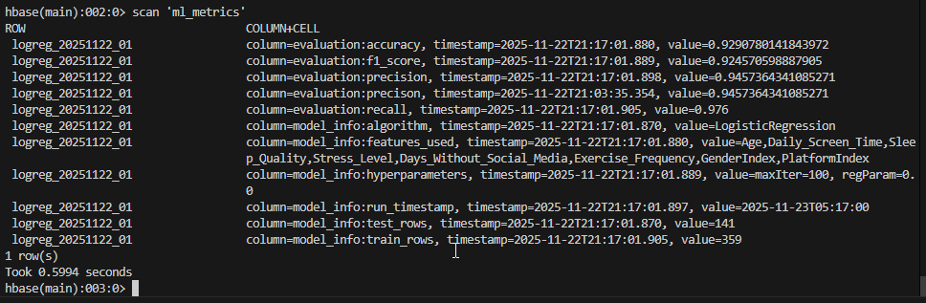
In this final table scan we can see the job did indeed populate the four metrics we discussed earlier into the evaluation column family. We also have all the model info data in the model_info column family. This scan shows that the spark job completed our python script and loaded the metrics successfully. It also confirms that the earlier steps in the process, such as loading the data into hive, also completed successfully. Seeing the machine learning metrics at the end shows that each step of the process was completed and we were able to obtain our result. With minimal changes to the script we can now test out other models and compare their performance.

Code
The github repository is available at https://github.com/hegemogy/bigdata and the script is available at https://github.com/hegemogy/bigdata/blob/main/final_project.py. The full content of the script is included here as well:
from pyspark.sql import SparkSession
from pyspark.ml.feature import StringIndexer, VectorAssembler
from pyspark.ml.classification import LogisticRegression
from pyspark.ml.evaluation import MulticlassClassificationEvaluator
from datetime import datetime
import happybase

# Step 1: Create Spark session
spark = (SparkSession.builder
.appName("MentalHealthSocialMediaML")
.enableHiveSupport()
.getOrCreate())

# Step 2: Load Hive table into Spark DataFrame
df = spark.sql(
"SELECT User_ID, Age, Gender, Daily_Screen_Time, Sleep_Quality, "
"Stress_Level, Days_Without_Social_Media, Exercise_Frequency, "
"Social_Media_Platform, Happiness_Index FROM user_social_media_data"
)

# Step 3: Handle null values
df = df.na.drop()

# Step 4: Encode categorical variables
gender_indexer = StringIndexer(
inputCol="Gender", outputCol="GenderIndex"
)
platform_indexer = StringIndexer(
inputCol="Social_Media_Platform", outputCol="PlatformIndex"
)

df = gender_indexer.fit(df).transform(df)
df = platform_indexer.fit(df).transform(df)

# Step 5: Create binary label (High Happiness = 1 if >=7, else 0)
df = df.withColumn("label", (df["Happiness_Index"] >= 7).cast("int"))

# Step 6: Assemble features
feature_cols = [
"Age", "Daily_Screen_Time", "Sleep_Quality", "Stress_Level",
"Days_Without_Social_Media", "Exercise_Frequency",
"GenderIndex", "PlatformIndex"
]

assembler = VectorAssembler(
inputCols=feature_cols, outputCol="features"
)
assembled_df = assembler.transform(df).select("features", "label")

# Step 7: Split into train/test
train_data, test_data = assembled_df.randomSplit([0.7, 0.3], seed=42)
train_rows = train_data.count()
test_rows = test_data.count()

# Step 8: Train Logistic Regression model
lr = LogisticRegression(featuresCol="features", labelCol="label")
lr_model = lr.fit(train_data)

# Step 9: Evaluate model
predictions = lr_model.transform(test_data)

evaluator_acc = MulticlassClassificationEvaluator(
labelCol="label", predictionCol="prediction", metricName="accuracy"
)
evaluator_f1 = MulticlassClassificationEvaluator(
labelCol="label", predictionCol="prediction", metricName="f1"
)
evaluator_precision = MulticlassClassificationEvaluator(
labelCol="label", predictionCol="prediction",
metricName="precisionByLabel"
)
evaluator_recall = MulticlassClassificationEvaluator(
labelCol="label", predictionCol="prediction",
metricName="recallByLabel"
)

accuracy = evaluator_acc.evaluate(predictions)
f1_score = evaluator_f1.evaluate(predictions)

# For binary classification, label 1 = "High Happiness"
precision = evaluator_precision.evaluate(
predictions, {evaluator_precision.metricLabel: 1}
)
recall = evaluator_recall.evaluate(
predictions, {evaluator_recall.metricLabel: 1}
)

print(f"Accuracy: {accuracy}")
print(f"F1 Score: {f1_score}")
print(f"Precision (High Happiness): {precision}")
print(f"Recall (High Happiness): {recall}")

row_key = "logreg_20251122_01"
model_info = {
"algorithm": "LogisticRegression",
"features_used": ",".join(feature_cols),
"hyperparameters": f"maxIter={lr.getMaxIter()}, "
f"regParam={lr.getRegParam()}",
"run_timestamp": datetime.now().strftime("%Y-%m-%dT%H:%M:%S"),
"train_rows": str(train_rows),
"test_rows": str(test_rows)
}
evaluation = {
"accuracy": accuracy,
"f1_score": f1_score,
"precision": precision,
"recall": recall
}

# ---- Step 10: Write metrics to HBase with HappyBase ----
data = []
for k, v in model_info.items():
data.append((row_key, f"model_info:{k}", str(v)))
for k, v in evaluation.items():
data.append((row_key, f"evaluation:{k}", str(v)))

def write_to_hbase_partition(partition):
connection = happybase.Connection('master')
connection.open()
table = connection.table('ml_metrics')
for row in partition:
row_key, column, value = row
table.put(row_key.encode(),
{column.encode(): value.encode()})
connection.close()

rdd = spark.sparkContext.parallelize(data)
rdd.foreachPartition(write_to_hbase_partition)

# Step 11: Stop Spark session
spark.stop()
Conclusion
This project tied together several concepts and components to create a single big data workflow. NiFi provided a visual layer that would be very useful in keeping a complicated system manageable. The Spark ML framework provided infinite capabilities with all the modules available in python for machine learning. Overall, the security of knowing that the data was durable and distributed would be a huge selling point in a production setting. All these components allowed us to extract real insights from the data and create a highly accurate model at predicting happiness from the other factors in the data. In the end we were left with a framework that could be used to ingest and process any kind and scale of data to derive useful findings.

References
Ayesha Imran. (2023). Social Media and Mental Health Balance [Data set]. Kaggle. https://www.kaggle.com/datasets/ayeshaimran123/social-media-and-mental-health-balance

